As we all are aware that **Apache** is a very powerful, highly flexible and configurable Web server for **Nix OS**. Here in this tutorial, we are going to discuss one more feature of **Apache** which allows us to host more than one website on a single Linux machine. Implementing virtual hosting with Apache web server can help you to save costs you are investing on your server maintenance and their administration.

Don’t Miss: [NGINX Name-based and IP-based Virtual Hosting (Server Blocks)](https://www.tecmint.com/nginx-name-based-and-ip-based-virtual-hosts-server-blocks/)

[](https://www.tecmint.com/wp-content/uploads/2014/01/Apache-Virtual-hosting.jpeg)

*Apache Virtual Hosting in Linux*

Concept of Shared web hosting and Reseller web hosting is based on this facility of Apache only.

Types of Virtual Host

There are two types of virtual hosting is available with Apache.

Name Based Virtual Hosting

With the name based virtual hosting you can host several domains/websites on a single machine with a singleIP. All domains on that server will be sharing a single IP. It’s easier to configure than IP based virtual hosting, you only need to configure DNS of the domain to map it with its correct IP address and then configure Apache to recognize it with the domain names.

[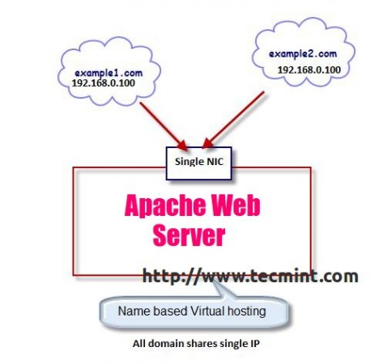](https://www.tecmint.com/wp-content/uploads/2014/01/Name-based-Virtual-hosting.jpeg)

*Name Based Virtual Hosting*

IP Based Virtual Hosting

With the IP based virtual hosting, you can assign a separate IP for each domain on a single server, these IP’s can be attached to the server with single NIC cards and as well as multiple NICs.

[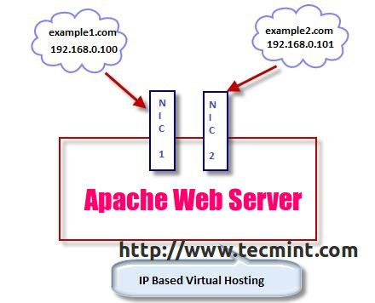](https://www.tecmint.com/wp-content/uploads/2014/01/IP-based-Virtual-Hosting.jpeg)

*IP Based Virtual Hosting*

Lets set up **Name Based Virtual Hosting** and **IP based Virtual hosting** in **RHEL, CentOS** and **Fedora**.

##### Testing Environment

1. **OS** – **CentOS 6.5**
2. **Application** – **Apache Web Server**
3. **IP Address** – **192.168.0.100**
4. **IP Address** – **192.168.0.101**
5. **Domain** – **www.example1.com**
6. **Domain** – **www.example2.com**

### How to Setup IP Based and Name Based Apache Virtual Hosts

Before setting up virtual hosting with **Apache**, your system must have Apache Web software installed. if not, install it using default package installer called yum.

[root@tecmint ~]# yum install httpd

#### Setup Name Based Virtual Host

But, before creating a virtual host, you need to create a directory where you will keep all your website’s files. So, create directories for these two virtual hosts under **/var/www/html** folder. Please remember **/var/www/html** will be your default **Document Root** in the Apache virtual configuration.

[root@tecmint ~]# mkdir /var/www/html/example1.com/

[root@tecmint ~]# mkdir /var/www/html/example2.com/

To set up Name based virtual hosting you must need to tell Apache to which IP you will be using to receive the Apache requests for all the websites or domain names. We can do this with **NameVirtualHost** directive. Open Apache main configuration file with **VI** editor.

[root@tecmint ~]# vi /etc/httpd/conf/httpd.conf

Search for **NameVirtualHost** and uncomment this line by removing the **#** sign in front of it.

NameVirtualHost

Next add the IP with possible in which you want to receive Apache requests. After the changes, your file should look like this:

NameVirtualHost 192.168.0.100:80

Now, it’s time to setup Virtual host sections for your domains, move to the bottom of the file by pressing **Shift + G**. Here in this example, We are setting up virtual host sections for two domains

1. **www.example1.com**
2. **www.example2.com**

Add the following two virtual directives at the bottom of the file. Save and close the file.

<VirtualHost 192.168.0.100:80>

ServerAdmin webmaster@example1.com

DocumentRoot /var/www/html/example1.com

ServerName www.example1.com

ErrorLog logs/www.example1.com-error_log

CustomLog logs/www.example1.com-access_log common

</VirtualHost>

<VirtualHost *:80>

ServerAdmin webmaster@example2.com

DocumentRoot /var/www/html/example2.com

ServerName www.example2.com

ErrorLog logs/www.example2.com-error_log

CustomLog logs/www.example2.com-access_log common

</VirtualHost>

You are free to add as many directives you want to add in your domains virtual host section. When you are done with changes in **httpd.conf** file, please check the syntax of files with following command.

[root@tecmint ~]# httpd -t

Syntax OK

It is recommended to check the syntax of the file after making some changes and before restarting the Web server because if any syntax goes wrong Apache will refuse to work with some errors and eventually affect your existing web server go down for a while. If syntax is **OK**. Please restart your Web server and add it to **chkconfig**to make your web server start in **runlevel 3** and **5** at the boot time only.

[root@tecmint ~]# service httpd restart

Stopping httpd: [ OK ]

Starting httpd: [ OK ]

[root@tecmint ~]# chkconfig --level 35 httpd on

Now it’s time to create a test page called **index.html** add some content to the file so we will have something to check it, when the IP calls the virtual host.

[root@tecmint ~]# vi /var/www/html/example1.com/index.html

<html>

<head>

<title>www.example1.com</title>

</head>

<body>

<h1>Hello, Welcome to www.example1.com.</h1>

</body>

</html>

[root@tecmint ~]# vi /var/www/html/example2.com/index.html

<html>

<head>

<title>www.example2.com</title>

</head>

<body>

<h1>Hello, Welcome to www.example2.com.</h1>

</body>

</html>

Once you’re done with it, you can test the setup by accessing both the domains in a browser.

http://www.example1.com

http://www.example2.com

##### Preview: www.example1.com

[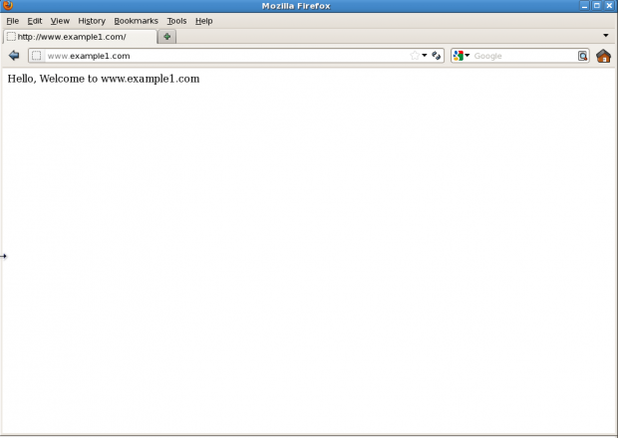](https://www.tecmint.com/wp-content/uploads/2014/01/example1.png)

*Virtual Hosting: www.example1.com*

##### Preview: www.example2.com

[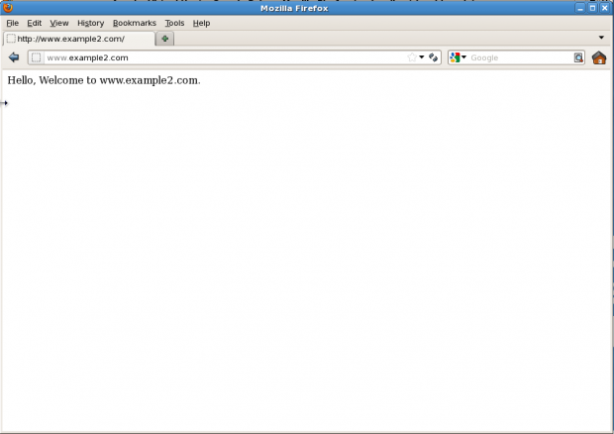](https://www.tecmint.com/wp-content/uploads/2014/01/example2.png)

*Virtual Hosting: www.example2.com*

#### Setup IP Based Virtual Hosting Linux

To setup IP based virtual hosting, you must have more than one **IP address**/**Port** assigned to your server or your Linux machine.

It can be on a single **NIC** card , For example: **eth0:1**, **eth0:2**, **eth0:3** … so forth. Multiple **NIC** cards can also be attached. If you don’t know how to create multiple IP’s on single **NIC**, follow the below guide, that will help you out in creating.

1. [Create Multiple IP Addresses to One Single Network Interface](https://www.tecmint.com/create-multiple-ip-addresses-to-one-single-network-interface/)

Purpose of implementing **IP based virtual hosting** is to assign implementing for each domain and that particular IP will not be used by any other domain.

This kind of set up required when a website is running with **SSL** certificate (**mod_ssl**) or on different ports and IPs. And You can also run multiple instances of Apache on a single machine. To check the IPs attached in your server, please check it using [ifconfig command](https://www.tecmint.com/ifconfig-command-examples/).

root@tecmint ~]# ifconfig

##### Sample Output

eth0 Link encap:Ethernet HWaddr 08:00:27:4C:EB:CE

inet addr:192.168.0.100 Bcast:192.168.0.255 Mask:255.255.255.0

inet6 addr: fe80::a00:27ff:fe4c:ebce/64 Scope:Link

UP BROADCAST RUNNING MULTICAST MTU:1500 Metric:1

RX packets:17550 errors:0 dropped:0 overruns:0 frame:0

TX packets:15120 errors:0 dropped:0 overruns:0 carrier:0

collisions:0 txqueuelen:1000

RX bytes:16565983 (15.7 MiB) TX bytes:2409604 (2.2 MiB)

eth0:1 Link encap:Ethernet HWaddr 08:00:27:4C:EB:CE

inet addr:192.168.0.101 Bcast:192.168.0.255 Mask:255.255.255.0

UP BROADCAST RUNNING MULTICAST MTU:1500 Metric:1

lo Link encap:Local Loopback

inet addr:127.0.0.1 Mask:255.0.0.0

inet6 addr: ::1/128 Scope:Host

UP LOOPBACK RUNNING MTU:16436 Metric:1

RX packets:1775 errors:0 dropped:0 overruns:0 frame:0

TX packets:1775 errors:0 dropped:0 overruns:0 carrier:0

collisions:0 txqueuelen:0

RX bytes:3416104 (3.2 MiB) TX bytes:3416104 (3.2 MiB)

As you can see in above output, two IPs **192.168.0.100** (**eth0**) and **192.168.0.101** (**eth0:1**) is attached to the server, both IPs are assigned to the same physical network device (**eth0**).

Now, assign a specific **IP**/**Port** to receive http requests, you can simply do it by changing **Listen** directive in **httpd.conf** file.

[root@tecmint ~]# vi /etc/httpd/conf/httpd.conf

Search for word “**Listen**”, You find a section where the short description about Listen directive is written. In that section, comment the original line and write your own directive below that line.

# Listen 80

Listen 192.168.0.100:80

Now,  create a Virtual host sections for both the domains. Go the bottom of the file and add the following virtual directives.

VirtualHost 192.168.0.100:80>

ServerAdmin webmaster@example1.com

DocumentRoot /var/www/html/example1

ServerName www.example1.com

ErrorLog logs/www.example1.com-error_log

TransferLog logs/www.example1.com-access_log

</VirtualHost>

<VirtualHost 192.168.0.101:80>

ServerAdmin webmaster@example2.com

DocumentRoot /var/www/html/example2

ServerName www.example2.com

ErrorLog logs/www.example2.com-error_log

TransferLog logs/www.example2.com-access_log

</VirtualHost>

Now, since you have modified main Apache conf file, you need to restart the http service like below.

[root@tecmint ~]# service httpd restart

Stopping httpd: [ OK ]

Starting httpd: [ OK ]

Test your IP based Virtual hosting setup by accessing the **URLs** on web browser as shown below.

http://www.example1.com

http://www.example2.com

That’s all with Apache virtual host today, If you’re looking to secure and harden your Apache configuration, then read our article that guides.

**Name Based Virtual hosting:**

<VirtualHost 172.31.37.0:80>

ServerAdmin www.bkpism1.com

DocumentRoot /var/www/html/bkp1.com

ServerName www.test1.com

ErrorLog logs/www.bkp1.com-error_log

CustomLog logs/www.bkp1.com-access_log common

</VirtualHost>

<VirtualHost *:80>

DocumentRoot /var/www/html/bkp2.com

ServerName www.bkpism2.com

</VirtualHost>

**OR**

<VirtualHost 172.31.37.0:80>

servername www.bukkapatnam1.com

DocumentRoot /var/www/html/test1

</VirtualHost>

<VirtualHost *:80>

servername www.bukkapatnam2.com

DocumentRoot /var/www/html/test2

</VirtualHost>

**Ip based virtual Hosting:**

<VirtualHost 172.31.37.0:80>

servername www.bukkapatnam1.com

DocumentRoot /var/www/html/test1

</VirtualHost>

<VirtualHost 172.31.397.1:80>

servername www.bukkapatnam2.com

DocumentRoot /var/www/html/test2

</VirtualHost>